Creative Voice Circle Audition Information
Creative Voice Circle Community:
Creative Voice Circle – Cynthia's Inspirations
Creative Voices Ensemble for Carnegie Hall Performance:
Creative Voices Ensemble – Cynthia's Inspirations

The Creative Voice Circle is a dynamic performance and service-based group of artists in partnership with the Lawrenceville-Suwanee School of Music. Rooted in our core values of artistry, service, and excellence, the collective is designed for poets, writers, and public speakers who seek both personal growth and meaningful community impact.
The first round of auditions for the Creative Voice Circle Ensemble will take place in person:
📍 Sunday, June 22nd | 3:00 PM – 8:00 PM EST
Location: Lawrenceville-Suwanee School of Music (Lawrenceville Campus)
1612 Collins Hill Rd, Lawrenceville, GA 30043
The second round of in-person auditions is scheduled for:
📍 Saturday, July 12th | 5:30 PM – 8:30 PM EST
Location: Same as above
If you're unavailable for either date, you may submit a virtual audition (via unlisted YouTube link) in place of the in-person audition. However, priority for final performer selection will be given to artists who are available to audition in person.
Creative Voice Circle auditions are for teenagers, college students, and adults.

Audition Guidelines
Prepare a 1–2-minute monologue, poem, or speech. Your piece should reflect your personal journey and your connection to a broader community, drawing inspiration from one or more of the following themes:

Audition Themes
- Resilience, Harmony, Voice, Unwritten, Stillness, Mosaic, Reflection, Symphony

Content Requirements
- No content with derogatory language, racism, bigotry, political agendas, or anything intended to be controversial.
- While pieces inspired by other authors are allowed, original work is preferred.

Time Limit
- Pieces must be 1–2 minutes long (do not exceed 2 minutes).

Slate Instructions (for All Auditions)
Start your audition (in-person or virtual) with a slate that includes:
- Your full name
- Your location (city and state)
- The name of your piece and whether it’s original or by another author.
- One example of how you’ve used your creative gifts to make a difference or why creative community matters to you as an artist.

How to Audition:
🎥 Virtual Auditions:
Submit your video as a YouTube link (unlisted) via email. The subject line is Audition_FirstNameLastName. Send to creativevoicecircle@gmail.com
📍 In-Person Auditions:
Sign Up Here – Creative Voice Circle: Auditions: Creative Voice Circle or Ensemble for Carnegie Performance
Confirmation of audition will be sent via email after you sign up.

Important Notes on the Carnegie Hall Opportunity
This audition is for acceptance into the Creative Voice Circle — a community performance group. While all accepted members will enjoy full benefits of participation (performance opportunities, connection, artistic development), only 3 members will be selected to perform at Carnegie Hall.

Carnegie Hall Performance Details
- Theme: Resilience (poetic group performance)
- Date/Time: Saturday, October 11th, 2025 | 1:00 PM
- Location: Weill Recital Hall, 154 W 57th St, New York, NY 10019
- Rehearsals: Mandatory in-person rehearsals in August/September
- Perks: Carnegie Hall resume credit + professional photos for your portfolio

Final Notes
You are welcome to audition even if you’re not pursuing the Carnegie Hall opportunity. Creative Voice Circle offers meaningful networking, growth, and performance opportunities throughout the year.
Questions?
You may ask during your audition or contact:
📧 — creativevoicecircle@gmail.com
Creative Voice Circle Community:
Creative Voice Circle – Cynthia's Inspirations
Creative Voices Ensemble for Carnegie Hall Performance:
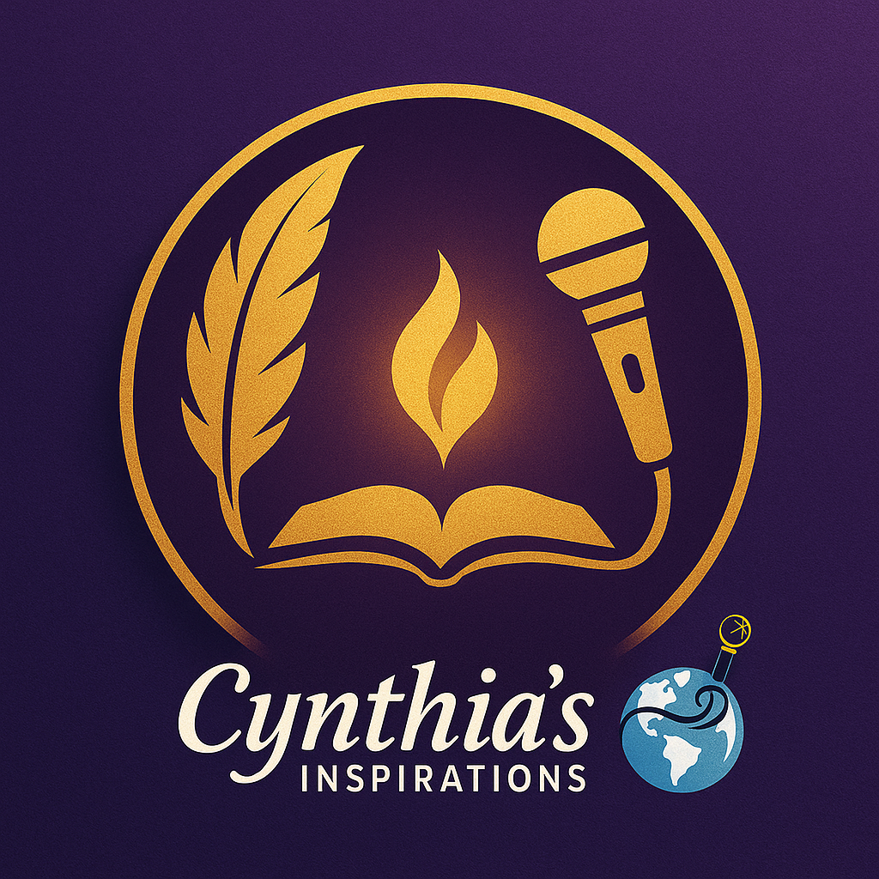
Creative Voices Ensemble – Cynthia's Inspirations

